SOUTHERN ENGLISH SETTER SOCIETY

Patron: Mrs. L. Cartledge
Chair: Mrs J Bishop

Hon Secretary:
Mr D Lewis
The Cider Press
Lower Coltscombe
Slapton
Devon TQ7 2QE

Tel: 01548 580600
Mobile: 07774 967167
e-mail: dave@lewkins.co.uk

President: Mrs A F Grimsdell
Vice-Chair: Mrs C Collins

Hon Treasurer:
Mr D Cozens
12 Chestnut Rise
Droxford
Hants SO32 3NY
01489-89878313
e-mail: dcozens@tiscali.co.uk
www.southernenglish.co.uk
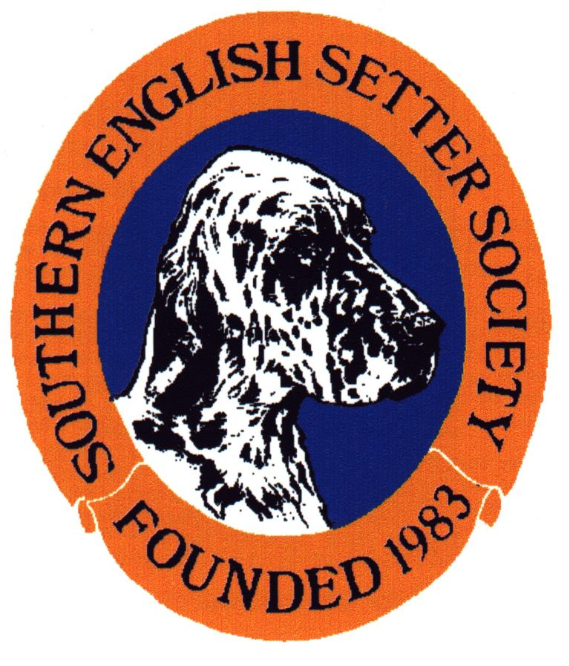

MEMBERSHIP APPLICATION

The Southern English Setter Society invites every owner of this breed to join us. The Society runs annually a Championship and an Open show along with occasional Educational Talks and workshops.

The annual fee for Members residing in the U.K. Inland postal rate is:-
£6.00 single, £7.50 joint. Overseas Members subscription is £7.50.

If you do not have a Proposer and/or Seconder please leave blank.

I wish to apply for Membership of the Southern English Setter Society:-

Please Print

NAME ……………………… TELEPHONE …………..………….…

ADDRESS ………………………

……………………………………… K.C. Prefix …………………………………
(if any)

……………………………………….

……………………………………….

………………………………………..

SIGNED …..…………. PROPOSED ………………. SECONDED ……………

I enclose my/our subscription for the current year (commencing 1st October)
*£6.00 (single) *£7.50 (joint) *£7.50 (overseas) in *Cash/PO/Cheque/Bankers Order.

Please make all Cheques / P.O.'s payable to:-

"SOUTHERN ENGLISH SETTER SOCIETY"

